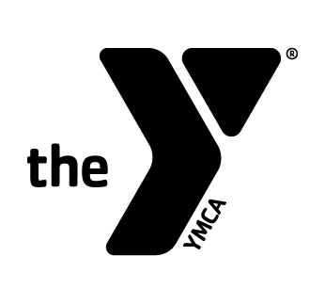
2019-2020 Aquaforce Swim Team Automatic Draft Form
- Please note that swimmers must be members of the Duncan YMCA. If you are not a current member, you will also need to complete a Membership Application. The draft for practice fees will take place on the first of each month.
(please print)
Date:_____________
Primary member’s name:________________________________________________
Phone Number:______________________________

BILLING:
Participant #1
Name:________________________________ Practice Group: I II III
Date of Birth: ___/___/___ Age:______ Start date:___________

Participant #2
Name:________________________________ Practice Group: I II III
Date of Birth: ___/___/___ Age:______ Start date:___________

Participant #3
Name:________________________________ Practice Group: I II III
Date of Birth: ___/___/___ Age:______ Start date:___________

_____________________________ ___________________
Member Signature Staff Signature

